TECHNICAL REPORT: STARTUP PROFIT ANALYSIS (PRDA-01)
Intern: Abdul Khadar J.
Email: abdulkhadarj911@gmail.com
Tool Stack: Microsoft Excel 2019, Power BI Desktop

1. PROJECT OVERVIEW
The purpose of this analysis is to identify the financial factors that drive profitability for startups. By analyzing a dataset of 50 startups, this report provides a mathematical model to predict profit based on Research & Development (R&D), Administration, and Marketing expenditures.

2. DATA ANALYSIS METHODOLOGY
- Tool: Excel 2019 Data Analysis Toolpak.
- Algorithm: Multiple Linear Regression.
- Target Variable: Profit.
- Features: R&D Spend, Administration, Marketing Spend.

3. STATISTICAL PERFORMANCE
The model was validated using key regression metrics to ensure high accuracy.
Regression Metric | Value
Multiple R | 0.975
R-Square | 0.9507
Adjusted R-Square | 0.9475
Interpretation: An R-Square of 0.9507 indicates that 95% of the change in profit is directly influenced by the spending variables analyzed in the model.

4. BUSINESS INSIGHTS
- Primary Profit Driver: R&D Spend has the highest positive correlation with profit. For every unit increase in R&D, profit increases significantly.
- Marketing Impact: Marketing spend is a secondary driver that consistently supports revenue growth.
- Operational Efficiency: Administrative costs showed the lowest impact on profit, indicating these are fixed overheads.

5. DATA VISUALIZATION (POWER BI)
An interactive dashboard (startup.pbix) was developed to allow stakeholders to:
- View profit trends across New York, California, and Florida.
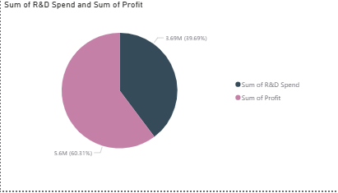
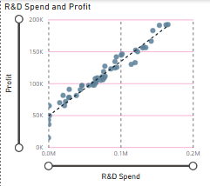
- Utilize a "What-If" Parameter to forecast profit instantly by adjusting spending sliders.
Figure 1: Executive Overview – Analysis of Profit and Expenditures across State Jurisdictions.
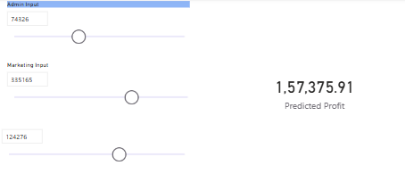
Figure 2: Predictive Modeling – Interactive "What-If" Parameter for Real-Time Profit Forecasting.
Figure 3: Segmented Analysis – Detailed breakdown of startup performance metrics.

